Module 3. Methods and encapsulation

Scope of variables

■ Local variables (also known as method-local variables)
■ Method parameters (also known as method arguments)
■ Instance variables (also known as attributes, fields, and nonstatic variables)
■ Class variables (also known as static variables)

Overlapping variable scopes

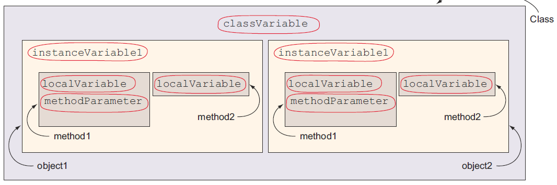

Figure. The scopes of variables can overlap

Create methods with arguments and return values

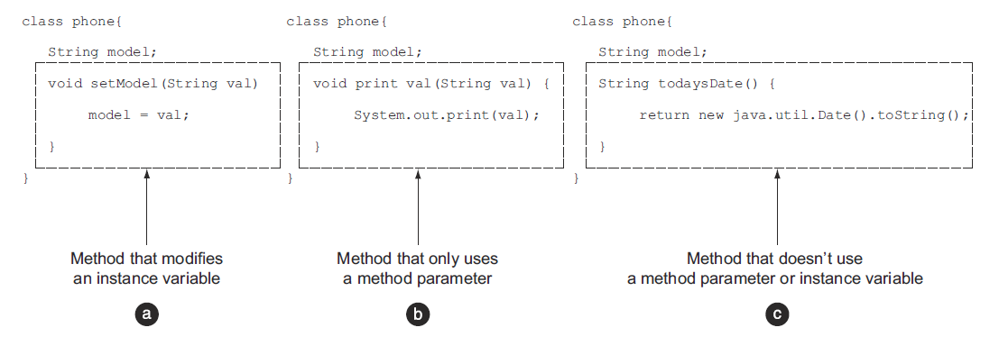

Method parameters

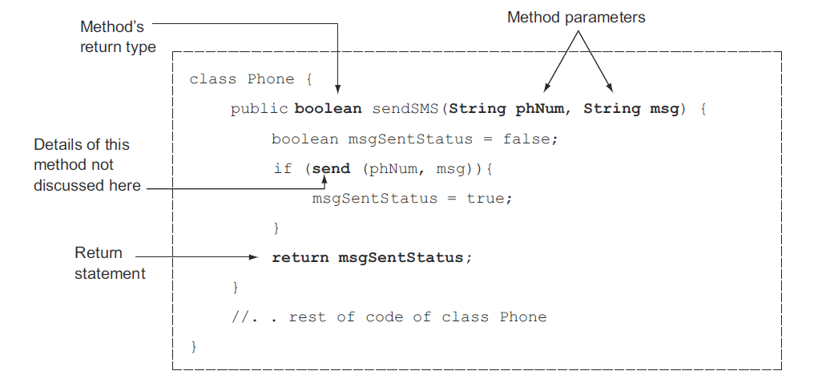

Figure. Different types of methods

Create an overloaded method

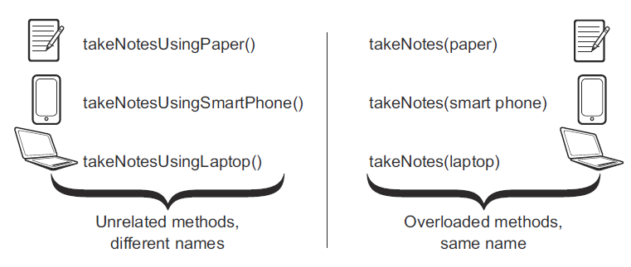

Figure. Real-life examples of overloaded methods

Passing object references to methods

WHEN METHODS REASSIGN THE OBJECT REFERENCES PASSED TO THEM

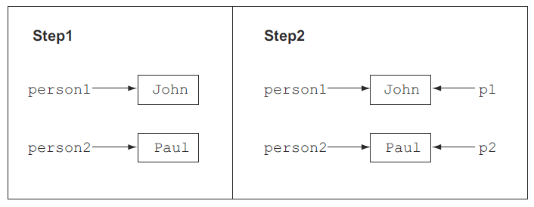

Figure. Objects of class Person, referred to by variables person1, person2, p1, and p2

WHEN METHODS MODIFY THE STATE OF THE OBJECT REFERENCES PASSED TO THEM

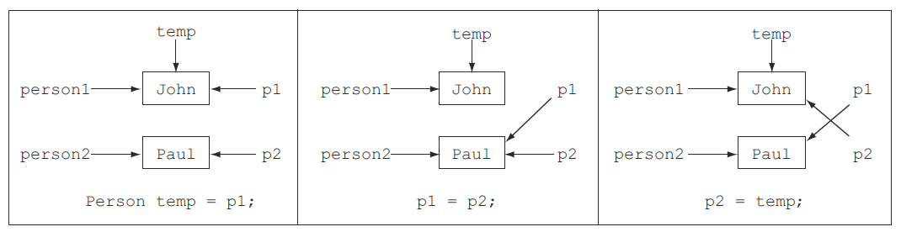

Figure. The change in the objects referred to by variables during the execution of the method swap

Review notes

Scope of variables:
■ Variables can have multiple scopes: class, instance, local, and method parameters.
■ Local variables are defined within a method. Loop variables are local to the loop within which they’re defined.
■ The scope of local variables is less than the scope of a method if they’re
declared in a sub-block (within braces, {}) in a method. This sub-block can be an if statement, a switch construct, a loop, or a try-catch block.
■ Local variables can’t be accessed outside the method in which they’re defined.
■ Instance variables are defined and accessible within an object. They’re accessible to all the instance methods of a class.
■ Class variables are shared by all of the objects of a class—they can be accessed even if there are no objects of the class.
■ Method parameters are used to accept arguments in a method. Their scope is limited to the method where they’re defined.
■ A method parameter and a local variable can’t be defined using the same name.
■ Class and instance variables can’t be defined using the same name.
■ Local and instance variables can be defined using the same name. In a method, if a local variable exists with the same name as an instance variable, the local variable takes precedence.

Object’s lifecycle:
■ An object’s lifecycle starts when it’s initialized and lasts until it goes out of scope or is no longer referenced by a variable.
■ When an object is alive, it can be referenced by a variable and other classes can use it by calling its methods and accessing its variables.
■ Declaring a reference object variable isn’t the same as creating an object.
■ An object is created using the operator new. Strings have special shorthand built into the compiler. Strings can be created by using double quotes, as in "Hello".
■ An object is marked as eligible for garbage collection when it can no longer be accessed.
■ An object can become inaccessible if it can no longer be referenced by any variable, which happens when a reference variable is explicitly set to null or when it goes out of scope.
■ You can be sure only about whether objects are marked for garbage collection. You can never be sure about whether an object has been garbage collected.

Create methods with arguments and return values:
■ The return type of a method states the type of value that a method will return.
■ You can define multiple method parameters for a method.
■ The method parameter can be of a primitive type or objects of a class or interface.
■ The method parameters are separated by commas.
■ Each method parameter is preceded by the name of its type. You can’t define the type of a method once, even when they’re of the same type (the way you can when declaring multiple variables of same type).
■ You can define only one variable argument in a parameter list, and it should be the final variable in the parameter list. If these two rules aren’t followed, your code won’t compile.
■ For a method that returns a value, the return statement must be followed immediately by a value.
■ For a method that doesn’t return a value (return type is void), the return statement must not be followed by a return value.
■ If there is code that can be executed only after a return statement, the class will fail to compile.
■ A method can optionally accept method arguments.
■ A method may optionally return a value.
■ A method returns a value by using the keyword return followed by the name of a variable, whose value is passed back to the calling method.
■ The returned value from a method may or may not be assigned to a variable. If the value is assigned to a variable, the variable type should be compatible with the type of the return value.
■ A return statement should be the last statement in a method. Statements placed after the return statement aren’t accessible and fail to compile.

Create an overloaded method:
■ Overloaded methods accept different lists of arguments. The argument lists can differ by
– Changes in the number of parameters that are accepted
– Changes in the types of parameters that are accepted
– Changes in the positions of parameters that are accepted
■ Methods can’t be defined as overloaded methods if they differ only in their return types or access modifiers.

Constructors of a class:
■ Constructors are special methods defined in a class that create and return an object of the class in which they’re defined.
■ Constructors have the same name as the class, and they don’t specify a return type—not even void.
■ User-defined constructors are defined by the developer.
■ Default constructors are defined by Java, but only if the developer doesn’t define any constructor in a class.
■ You can define a constructor using the four access modifiers: public, protected, default, and private.
■ If you define a return type for a constructor, it’ll no longer be treated like a constructor. It’ll be treated like a regular method, even though it shares the same name as its class.
■ An initializer block is defined within a class, not as a part of a method. It executes for every object that’s created for a class.
■ If you define both an initializer and a constructor for a class, both of these will execute. The initializer block will execute prior to the constructor.
■ Unlike constructors, an initializer block can’t accept method parameters.
■ An initializer block can create local variables. It can access and assign values to instance and static variables. It can call methods and define loops, conditional statements, and try-catch-finally blocks.

Overloaded constructors:
■ A class can also define overloaded constructors.
■ Overloaded constructors should be defined using different argument lists.
■ Overloaded constructors can’t be defined by just a change in the access modifiers.
■ Overloaded constructors may be defined using different access modifiers.
■ A constructor can call another overloaded constructor by using the keyword this.
■ A constructor can’t invoke a constructor by using its class’s name.
■ If present, a call to another constructor should be the first statement in
a constructor.

Accessing object fields:
■ An object field is another name for an instance variable defined in a class.
■ An object field can be read by either directly accessing the variable (if its access modifier permits) or by using a method that returns its value.
■ An object field can be written by either directly accessing the variable (if its access modifier permits) or by using constructors and methods that accept a value and assign it to the instance variable.
■ You can call methods defined in a class using an object reference variable.
■ When calling a method, it must be passed the correct number and type of method arguments.

Applying encapsulation principles to a class:
■ A well-encapsulated object doesn’t expose the internal parts of an object outside it. It defines a set of well-defined interfaces (methods), which enables the users of the class to interact with it.
■ A class that isn’t well encapsulated is at risk of being assigned undesired values for its variables by the callers of the class, which can make the state of an object unstable.
■ By exposing object functionality only through methods, you can prevent private variables from being assigned values that don’t fit your requirements.
■ The terms encapsulation and information hiding are also used interchangeably.
■ One of the best ways to define a well-encapsulated class is to define its instance variables as private variables and allow access to these variables using methods.

Passing objects and primitives to methods:
■ Objects and primitives behave in different manners when they’re passed to a method, because of differences in the way these two data types are internally stored by Java.
■ When you pass a primitive variable to a method, its value remains the same after the execution of the method. This doesn’t change, regardless of whether the method reassigns the primitive to another variable or modifies it.
■ When you pass an object to a method, the method can modify the object’s state by executing its methods. In this case, the modified state of the object is reflected in the calling method.

Sample questions

Q3-1. How can you include encapsulation in your class design?
a Define instance variables as private members.
b Define public methods to access and modify the instance variables.
c Define some of the instance variables as public members.
d All of the above.

Q3-2. Examine the following code and select the correct option(s):
public class Person {
public int height;
public void setHeight(int newHeight) {
if (newHeight <= 300)
height = newHeight;
}
}
a The height of a Person can never be set to more than 300.
b The previous code is an example of a well-encapsulated class.
c The class would be better encapsulated if the height validation weren’t set
to 300.
d Even though the class isn’t well encapsulated, it can be inherited by other classes.

Q3-3. Which of the following methods correctly accepts three whole numbers as method arguments and returns their sum as a decimal number?
a public void addNumbers(byte arg1, int arg2, int arg3) {
double sum = arg1 + arg2 + arg3;
}
b public double subtractNumbers(byte arg1, int arg2, int arg3) {
double sum = arg1 + arg2 + arg3;
return sum;
}
c public double numbers(long arg1, byte arg2, double arg3) {
return arg1 + arg2 + arg3;
}
d public float wakaWakaAfrica(long a1, long a2, short a977) {
double sum = a1 + a2 + a977;
return (float)sum;
}

Q3-4. Which of the following statements are true?
a If the return type of a method is int, the method can return a value of type byte.
b A method may or may not return a value.
c If the return type of a method is void, it can define a return statement without a value, as follows:
return;
d A method may or may not accept any method arguments.
e A method must accept at least one method argument or define its return type.
f A method whose return type is String can’t return null.

Q3-5. Given the following definition of class Person,
class Person {
public String name;
public int height;
}
what is the output of the following code?
class EJavaGuruPassObjects1 {
public static void main(String args[]) {
Person p = new Person();
p.name = "EJava";
anotherMethod(p);
System.out.println(p.name);
someMethod(p);
System.out.println(p.name);
}
static void someMethod(Person p) {
p.name = "someMethod";
System.out.println(p.name);
}
static void anotherMethod(Person p) {
p = new Person();
p.name = "anotherMethod";
System.out.println(p.name);
}
}
a anotherMethod
anotherMethod
someMethod
someMethod
b anotherMethod
EJava
someMethod
someMethod
c anotherMethod
EJava
someMethod
EJava
d Compilation error.

Q3-6. What is the output of the following code?
class EJavaGuruPassPrim {
public static void main(String args[]) {
int ejg = 10;
anotherMethod(ejg);
System.out.println(ejg);
someMethod(ejg);
System.out.println(ejg);
}
static void someMethod(int val) {
++val;
System.out.println(val);
}
static void anotherMethod(int val) {
val = 20;
System.out.println(val);
}
}
a 20
10
11
11
b 20
20
11
10
c 20
10
11
10
d Compilation error

Q3-7. Given the following signature of method eJava, choose the options that correctly overload this method:
public String eJava(int age, String name, double duration)
a private String eJava(int val, String firstName, double dur)
b public void eJava(int val1, String val2, double val3)
c String eJava(String name, int age, double duration)
d float eJava(double name, String age, byte duration)
e ArrayList<String> eJava()
f char[] eJava(double numbers)
g String eJava()

Q3-8. Given the following code,
class Course {
void enroll(long duration) {
System.out.println("long");
}
void enroll(int duration) {
System.out.println("int");
}
void enroll(String s) {
System.out.println("String");
}
void enroll(Object o) {
System.out.println("Object");
}
}
what is the output of the following code?
class EJavaGuru {
public static void main(String args[]) {
Course course = new Course();
char c = 10;
course.enroll(c);
course.enroll("Object");
}
}
a Compilation error
b Runtime exception
c int
String
d long
Object

Q3-9. Examine the following code and select the correct options:
class EJava {
public EJava() {
this(7);
System.out.println("public");
}
private EJava(int val) {
this("Sunday");
System.out.println("private");
}
protected EJava(String val) {
System.out.println("protected");
}
}
class TestEJava {
public static void main(String[] args) {
EJava eJava = new EJava();
}
}

a The class EJava defines three overloaded constructors.
b The class EJava defines two overloaded constructors. The private constructor isn’t counted as an overloaded constructor.
c Constructors with different access modifiers can’t call each other.
d The code prints the following:
protected
private
public
e The code prints the following:
public
private
protected

Q3-10. Select the incorrect options:
a If a user defines a private constructor for a public class, Java creates a public default constructor for the class.
b A class that gets a default constructor doesn’t have overloaded constructors.
c A user can overload the default constructor of a class.
d The following class is eligible for a default constructor:
class EJava {}
e The following class is also eligible for a default constructor:
class EJava {
void EJava() {}
}

